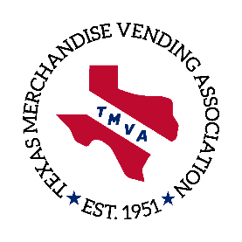
TMVA 2019 Annual Convention
Sept. 25-27 | Lost Pines Resort| Austin
Sponsorship Form

Fill out form and pay online!
https://www.cognitoforms.com/NAMA/TMVASponsorshipForm
Credit card payments only accepted online

Support TMVA while increasing your company’s visibility and showing your commitment to the industry. Your sponsorship donation will be used to fund various TMVA functions during our 2019 Convention such as programs, speakers, networking events and business meetings.

Please Print

Contact Name: _____________________________________________________________ E-mail: _____________________________________

Company :_________________________________________________________________ Phone: _____________________________________

Company Address: _______________________________________ City:_____________________________ State: ________ Zip:_____________

If you have any questions concerning sponsorships, please contact Michael Allen- michaela@gandj.com
Donating a Gift or Door Prize?
Please Describe:
___________________________________________
___________________________________________
___________________________________________
___________________________________________
___________________________________________
___________________________________________
Valued at: $__________________________________
Please Indicate Your Desired Level of Sponsorship

Platinum $2000
Gold $1000
Silver $ 500
Blue $ 300

Form & payment must be received by SEPT. 6, 2019
for company name to be printed on signs & in program

Send form and check, payable to TMVA, to: TMVA – C/O David Clayton – PO Box 16046 – Austin, TX 78761.

If paying with credit card - https://www.cognitoforms.com/NAMA/TMVASponsorshipForm

